**Project Report**

### ***Smart Lender - Applicant Credibility Prediction for Loan Approval***

**1.INTRODUCTION:**

**1.1 PROJECT OVERVIEW:**

The most valuable component of any economy is its banks. When assessing a country's progress, factors like banks, interest rates, and borrowings should be taken into account. Payment of cash obtained back from borrowers makes up a significant portion of supporting credit distribution activities in addition to raising resources through new deposits, borrowings, etc.

Bank management aims to keep the losses at low level. By using machine learning algorithms, loan approval process can be done easily. This is a categorization issue where we must classify whether or not the loan will be accepted. In a problem in predictive modelling known as classification, a class label is predicted for a specific example of input data. Using the information supplied by the borrower, an entity is expected to automate the loan qualification process. The loan amount, the borrower's name, marital status, income, credit history, level of education, the number of dependents, and a few other details are required when submitting a request form.

**1.2 PURPOSE:**

Project Objective: To automate the loan eligibility process real-time based on customer detail provided while filling out online application forms. These details are Gender, Marital Status, Education, number of Dependents, Income, Loan Amount, Credit History, and others. They have provided a dataset to identify the customer segments that are eligible for loan amounts so that they can specifically target these customers.

Technical aspects that we would get if we complete this project:

1. Knowledge of Machine Learning Algorithms.

2. Knowledge of Python Language with Machine Learning.

3. Understand about Classification and regression problem.

4. Know about pre-processing/clean the data using different data pre-processing techniques.

5. Applying different algorithms according to the dataset and based on visualization.

6. Real-Time Analysis of Project.

7. Building ease of User Interface (UI).

8. Navigation of ideas towards other projects(creativeness).

9. Knowledge of building ML model. 10.Build web applications using the Flask framework.

**2.LITERATURE SURVEY**

**2.1 EXIXTING PROBLEM:**

Loans are no longer considered a last resort to buy a sought-after smartphone or a dream house. Over the last decade or so, people have become less hesitant in applying for a loan, whether it’s personal, vehicle, education, business, or home – especially when they don’t have a lump sum at their disposal. Besides, Home and Education Loans provide tax advantages that reduce tax liability and increase the cash in hand from salary income.

It also helps that banks are making it easier for customers and prospective borrowers to get loans with minimal paperwork, quick eligibility checks, and competitive interest rates. They have opened an online channel to apply and submit documents for the approval process

However, the viability of this loan cycle may be harmed if the banks are unable to recover the lent sum. The majority of a bank's revenue comes from the amount of interest it charges on loans and if banks are unable to collect these sums, it has an impact on not only their profitability but also their everyday functioning.

**2.2 REFERENCES:**

1. Sheikh, M. A., Goel, A. K., & Kumar, T. (2020). An Approach for Prediction of Loan Approval using Machine Learning Algorithm. 2020 International Conference on Electronics and Sustainable Communication Systems (ICESC).

2. Pidikiti Supriya, Myneedi Pavani, Nagarapu Saisushma,Namburi Vimala Kumari, k Vikash,“Loan Prediction by using Machine Learning Models”, International Journal of Engineering and Techniques.Volume 5 Issue 2, Mar-Apr 2019

3. Nikhil Madane, Siddharth Nanda,”Loan Prediction using Decision tree”, Journal of the Gujrat Research History, Volume 21 Issue 14s, December 2019.

4. Amruta S. Aphale and R. Prof. Dr. Sandeep. R Shinde, “Predict Loan Approval in Banking System Machine Learning Approach for Cooperative Banks Loan Approval”, International Journal of Engineering Trends and Applications (IJETA), vol. 9, issue 8, 2020).

**2.3 PROBLEM STATEMENT DEFINITION:**

Modernized loan prediction system is based on Machine Learning approach where we can find out whether the loan will pass or not. This system requires data from the users like loan duration, monthly income, loan amount, monthly income etc. According to the parameters provided, the bank decides whether the customer gets the loan or not.

Thus, a classification system exists. In this system, a training set is used to create the model and the classifier will be able to categorise the data items into respective classes. In order to train the data and provide the correct outcome, which is the client's potential and ability to repay the loan, a test dataset is constructed. For banks and customers alike, the prediction of a modernised loan approval system is quite helpful. This method evaluates each candidate based on their priority. The customer can submit their application directly to the bank, in which case the bank will handle the entire procedure without interference from a third party or stockholder. Finally, based on its priority system, the bank will determine if the candidate is deserving or not. The sole goal of this is to ensure that the deserving candidate receives simple and rapid results.

**3.IDEATION &PROPOSED SOLUTION**

**3.1 EMPATHY MAP CANVAS:**

An empathy map is a simple, easy-to-digest visual that captures knowledge about a user’s behaviours and attitudes. It is a useful tool to helps teams better understand their users. Creating an effective solution requires understanding the true problem and the person who is experiencing it. The exercise of creating the map helps participants consider things from the user’s perspective along with his or her goals and challenges.

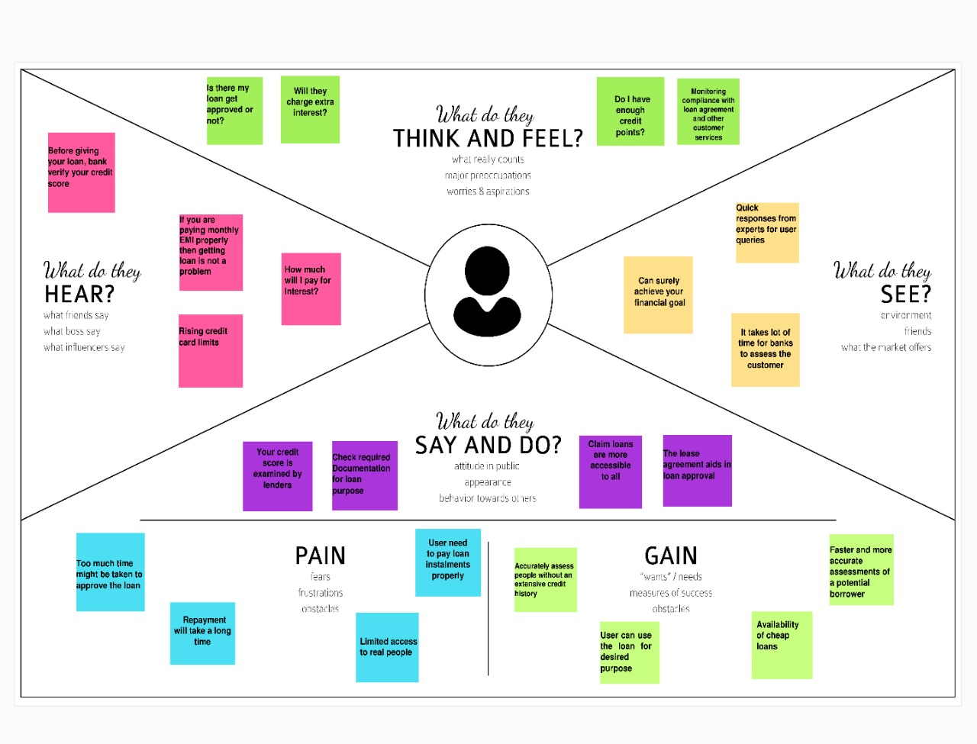

**3.2 IDEATION & BRAINSTROMING:**

Brainstorming provides a free and open environment that encourages everyone within a team to participate in the creative thinking process that leads to problem solving. Prioritizing volume over value, out-of-the-box ideas are welcome and built upon, and all participants are encouraged to collaborate, helping each other develop a rich number of creative solutions. This template shows in our own brainstorming sessions so our team can unleash the imagination and start shaping concepts even if not sitting in the same room.

Step-1: Team Gathering, Collaboration and Select the Problem Statement.

Step-2: Brainstorm, Idea Listing and Grouping

Step-3: Idea Prioritization

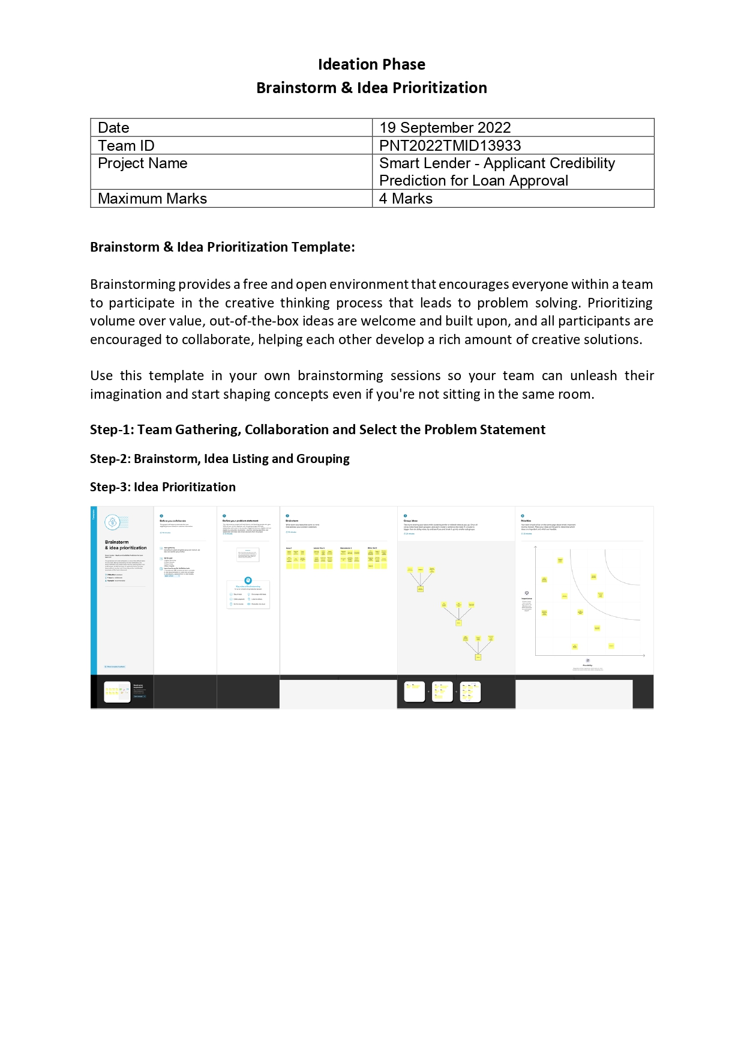

**3.3 PROPOSED SOLUTION:**

|  |  |  |
| --- | --- | --- |
| **S.NO** | **PARAMETER** | **DESCRIPTION** |
| **1** | Problem Statement (Problem to be solved) | The banking and finance professionals who are providing their candidate with a 100% loan will be able to determine whether or not the applicant is suitable for loan approval. |
| **2** | Idea / Solution description | In order to anticipate if the consumer is eligible for the loan, we are developing a machine learning model that takes into account a variety of data elements, including credit history, duration time, and credit mix. Both classification and regression tasks perform efficiently using the Decision Tree Algorithm. Loan predictions and their seriousness can be predicted using various analytical approaches |
| **3** | Novelty / Uniqueness | The machine learning algorithm makes an accurate estimate of the customer's credit eligibility using a variety of data inputs. |
| **4** | Social Impact / Customer Satisfaction | This will lessen all fraud committed at the time of approval, forecast loan approvals, and automate loan approvals. |
| **5** | Business Model (Revenue Model) | This model can be created for a reasonable price. It will simultaneously deliver maximum performance, high precision, and the outcome will be more efficient than the conventional procedures. |
| **6** | Scalability of the Solution | Software can be modified such that it will receive new testing data, participate in training data, and generate predictions based on that data. Module might be upgraded and made more integrated for future forecasting |

**3.4 PROBLEM SOLUTION FIT:**

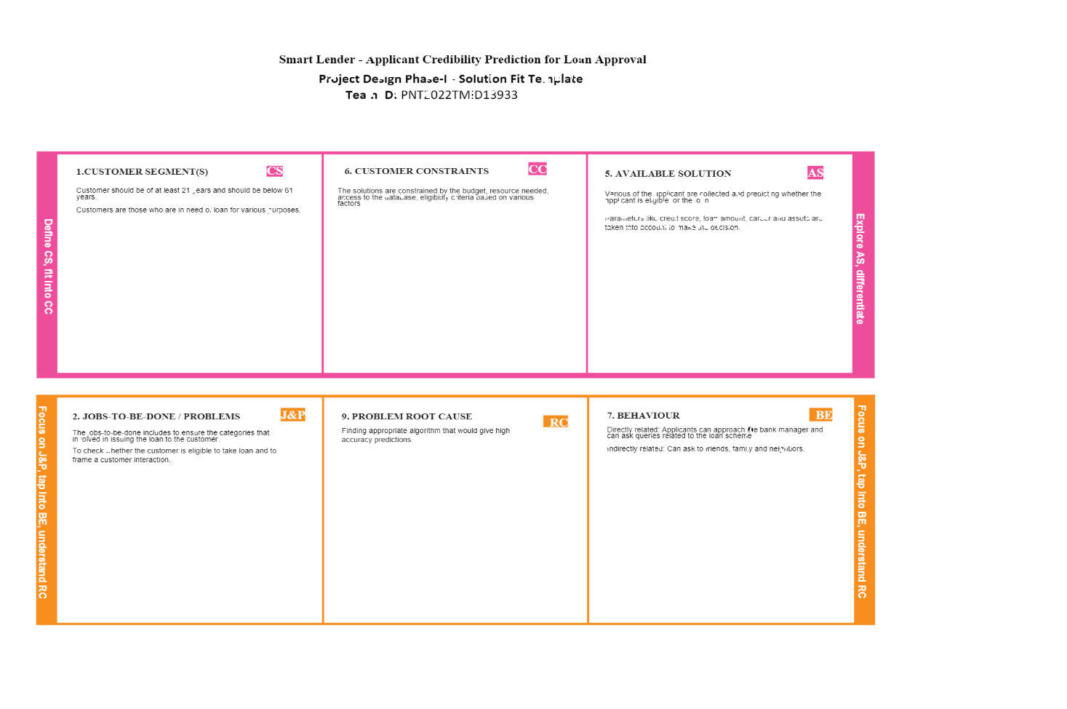



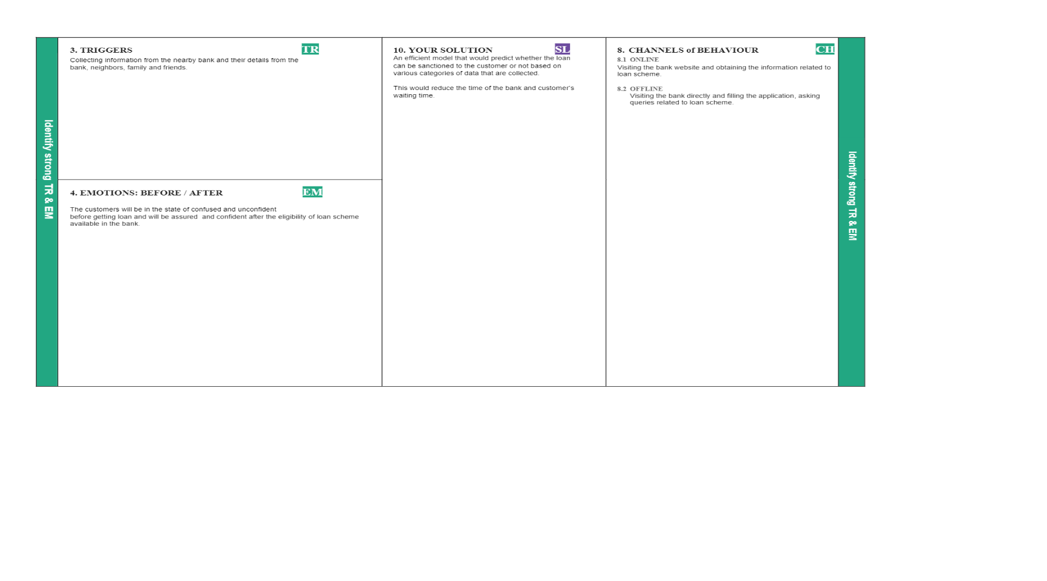

**4.1 REQUIREMENT ANALYSIS**

**4.1 FUNCTIONAL REQUIREMENT:**

Following are the functional requirements of the proposed solution.

|  |  |  |
| --- | --- | --- |
| **FR No.** | **Functional Requirement (Epic)** | **Sub Requirement (Story / Sub-Task)** |
| FR-1 | User Registration | Registration through Form Registration through Gmail  Enter Mail Id and other personal details required for registration |
| FR-2 | User Confirmation | Confirmation via Email Confirmation via OTP |
| FR-3 | User Application | Verification of Application  Updation of their bank details to check their credentiality |
| FR-4 | User credit score check | Confirms through our proprietary software which evaluates  Categorizes users according to credit history |
| FR-5 | User Loan details | Validated by bank or financial institution Credit score and Income Auditing |
| FR-6 | Result | If Approved - Displays the information what to be done next  If Declined – Displays not eligible for the loan |

**4.2 NON-FUNCTIONAL REQUIREMENT:**

Following are the non-functional requirements of the proposed solution.

|  |  |  |
| --- | --- | --- |
| **FR No.** | **Non-Functional Requirement** | **Description** |
| NFR-1 | **Usability** | The application's interface will be organised and tidy, and it will be simple to use. The programme is accessible to users in nearly all web browsers. |
| NFR-2 | **Security** | Customers are asked to create an account using their Email or using One Time Password through their registered mobile number making it more secure and it enhances security features to update the documents of users |
| NFR-3 | **Reliability** | Bugs will be detected and fixed as soon as possible making the application even more reliable and trust-worthy |
| NFR-4 | **Performance** | As soon as bugs are found, they will be corrected, making the application even more reliable and trustworthy. |
| NFR-5 | **Availability** | Since it is platform independent, users can access using any operating system. Application is accessible round-the-clock due to IBM Cloud hosting |
| NFR-6 | **Scalability** | As the user base expands, cross-platform mobile applications might be created in the future. |

**5.PROJECT DESIGN**

**5.1 DATA FLOW DIAGRAMS:**

Data Flow Diagrams:

A Data Flow Diagram (DFD) is a traditional visual representation of the information flows within a system. A neat and clear DFD can depict the right amount of the system requirement graphically. It shows how data enters and leaves the system, what changes the information, and where data is stored.

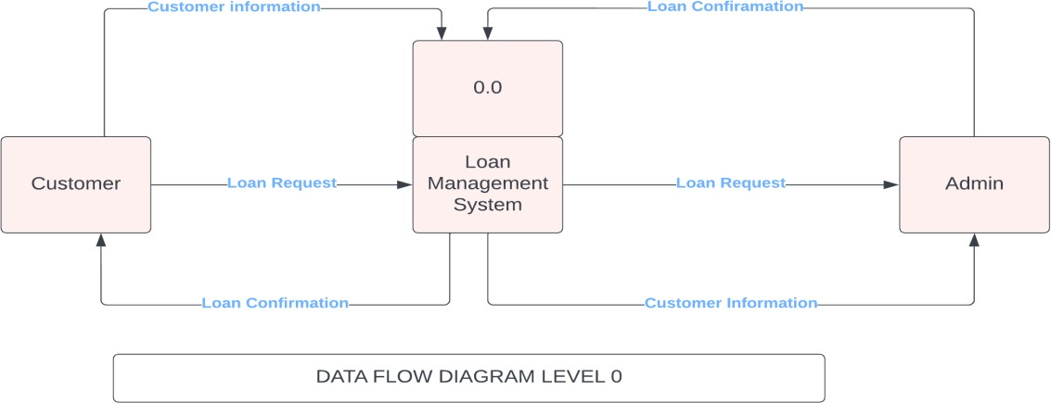

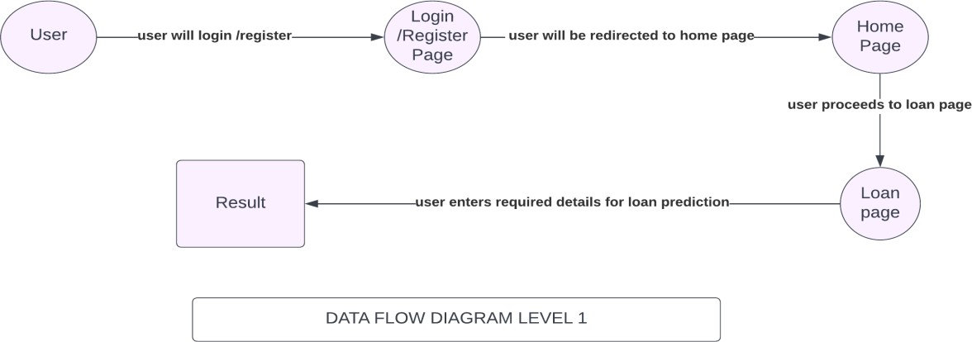

**5.2 SOLUTION AND TECHNICAL ARCHITECTURE:**

Solution architecture is a complex process – with many sub-processes – that bridges the gap between business problems and technology solutions. Its goals are to:

* Find the best tech solution to solve existing business problems.
* Describe the structure, characteristics, behaviour, and other aspects of the software to project stakeholders.
* Define features, development phases, and solution requirements.
* Provide specifications according to which the solution is defined, managed, and delivered.

# Example - Solution Architecture Diagram:

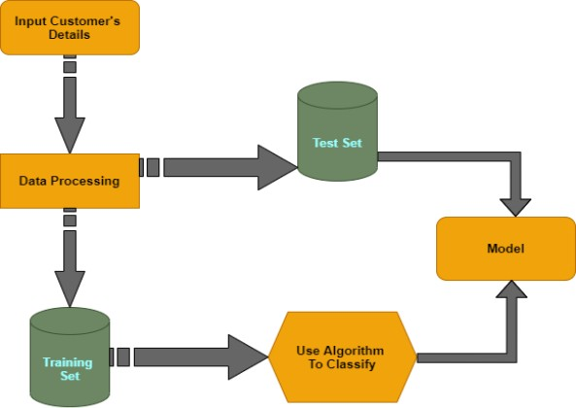

**5.3 USER STORIES**

|  |  |  |  |  |  |  |
| --- | --- | --- | --- | --- | --- | --- |
| **User Type** | **Functional Requirement**  **(Epic)** | **User Story**  **Number** | **User Story / Task** | **Acceptance criteria** | **Priority** | **Release** |
| Customer | Registration | USN-1 | As a user, I can register | I can access my | High | Sprint-1 |
| (Mobile user) |  |  | for the application by | account / |  |  |
|  |  |  | entering my email, | dashboard |  |  |
|  |  |  | password, and confirming |  |  |  |
|  |  |  | my password. |  |  |  |
|  |  | USN-2 | As a user, I will receive | I can receive | High | Sprint-1 |
|  | confirmation email once I | confirmation email |  |  |
|  | have registered for the | & click confirm |  |  |
|  | application |  |  |  |
|  |  | USN-3 | As a user, I can register | I can register & | Low | Sprint-2 |
|  | for the application through | access the |  |  |
|  | Facebook | dashboard with |  |  |
|  |  | Facebook Login |  |  |
|  |  | USN-4 | As a user, I can register for the application through  Gmail | I can receive confirmation email  & check confirm. | Medium | Sprint-1 |
|  | Login | USN-5 | As a user, I can log into the application by entering email & password | Able to login | High | Sprint-1 |
|  | Dashboard | USN-6 | As a user, I should be | Access the | Medium | Sprint-1 |
|  |  | able to access the | dashboard. |  |  |
|  |  | dashboard with |  |  |  |
|  |  | everything I am allowed to |  |  |  |
|  |  | use. |  |  |  |
| Customer | Registration | USN-7 | As a user, I can register | I can access my | High | Spring-1 |
| (Web user) |  |  | for the application by | account/dashboard |  |  |
|  |  |  | entering my email, |  |  |  |
|  |  |  | password, and confirming |  |  |  |
|  |  |  | my password. |  |  |  |
|  |  | USN-8 | As a user, I will receive | I can receive | High | Spring-1 |
|  | confirmation email once I | confirmation |  |  |
|  | have registered for the | email& click |  |  |
|  | application. | confirm |  |  |
|  |  | USN-9 | AS a user, I can register | I can access my | Low | Spring-1 |
|  | for the application through | account the |  |  |
|  | Facebook. | dashboard with |  |  |
|  |  | Facebook Login. |  |  |
|  |  | USN-10 | As a user, I can register | I can receive | Medium | Spring-1 |
|  | for the application through | confirmation |  |  |
|  | Gmail. | email& click |  |  |
|  |  | confirm |  |  |
|  | Login | USN-11 | As a user, I can log into the application by entering email &  password. | Able to login | High | Sprint-1 |
|  | Dashboard | USN-12 | As a user, I should be | Access the | Medium | Sprint-1 |
|  |  | able to access the | Dashboard. |  |  |
|  |  | dashboard with |  |  |  |
|  |  | everything I am allowed to |  |  |  |
|  |  | use. |  |  |  |
| Customer |  | USN-13 | As a Customer Care | Access my | Medium | Sprint 3 |
| Care |  | Executive, I should be | account |  |  |
| Executive |  | able to solve queries by |  |  |  |
|  |  | interacting with users. |  |  |  |

|  |  |  |  |  |  |  |
| --- | --- | --- | --- | --- | --- | --- |
| Administrator | Register | USN-14 | As an Admin I should be able to register myself with unique Email, Password | Able to Register | Medium | Sprint-4 |
|  | Login | USN-14 | As an Admin I should be able to login myself with unique Email, Password | Able to Login | Medium | Sprint-4 |
|  | Dashboard | USN-15 | As an Admin, I should be able to access the  dashboard. | Access the dashboard | Medium | Sprint 4 |

**6.PROJECT PLANNING AND SCHEDULING**

**6.1 SPRINT PLANNING AND ESTIMATION**

|  |  |  |  |  |  |
| --- | --- | --- | --- | --- | --- |
| **Sprint** | **Functional requirement (Epic)** | **Task** | **Points** | **Priority** | **Team Members** |
| Sprint -1 | Dataset | Downloading the dataset | 1 | High | Meenalakshmi S |
| Sprint -1 |  | Visualizing the dataset | 2 | Low | Komal T Lekshmipriya S  Meenalakshmi S Mithra Devi R |
| Sprint -1 |  | Pre-processing the dataset | 3 | Medium | Komal T Lekshmipriya S  Meenalakshmi S Mithra Devi R |
| Sprint -1 | Machine learning Model | KNN model building | 5 | High | Meenalakshmi S Mithra Devi R |
| Sprint -2 |  | Decision Tree model building | 5 | High | Komal T Lekshmipriya S |
| Sprint -2 |  | Xgboost Model Building | 5 | High | Meenalakshmi S Mithra Devi R |
| Sprint- |  | Random Forest model | 3 | Low | Komal T  Lekshmipriya S |
| Sprint -2 |  | Evaluation and saving of the models | 5 | High | Lekshmipriya S |
| Sprint -3 | Customer User Interface | Model Integration with Flask | 5 | High | Meenalakshmi S Mithra Devi R |
| Sprint -3 |  | Building Html pages Build python code | 3 | Medium | Komal T Mithra Devi R Meenalakshmi S |
| Sprint -3 |  | Select the type of loan | 3 | Low | Meenalakshmi S Lekshmipriya S |
| Sprint -3 |  | Fill the Application and check the eligibility of the loan approval | 5 | High | Mithra Devi R Lekshmipriya S |
| Sprint -4 | Deployed the website | Register on IBM Cloud | 3 | Low | Komal T |
| Sprint -4 |  | Train the ML model on IBM Cloud | 5 | Medium | Komal T Lekshmipriya S |

**6.2SPRINT DELIVERY SCHEDULE**

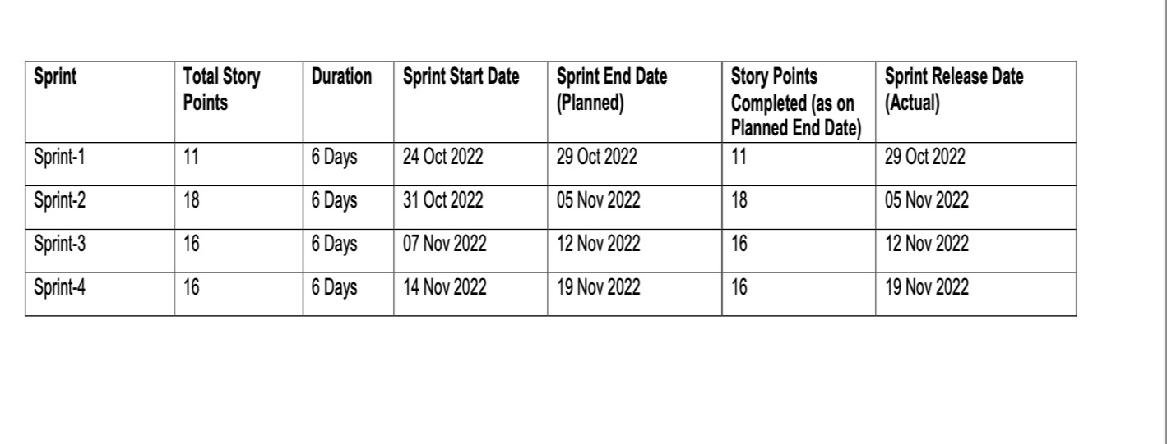

**6.3 REPORTS FROM JIRA**

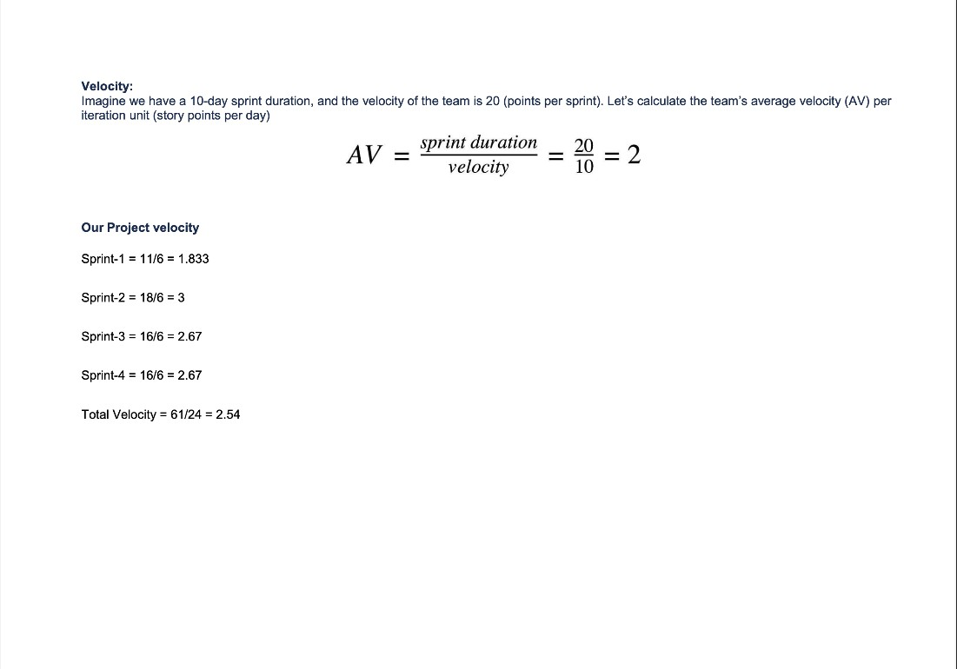

**7.CODING &SOLUTION**

**7.1 FEATURE 1:FORM FILLING**

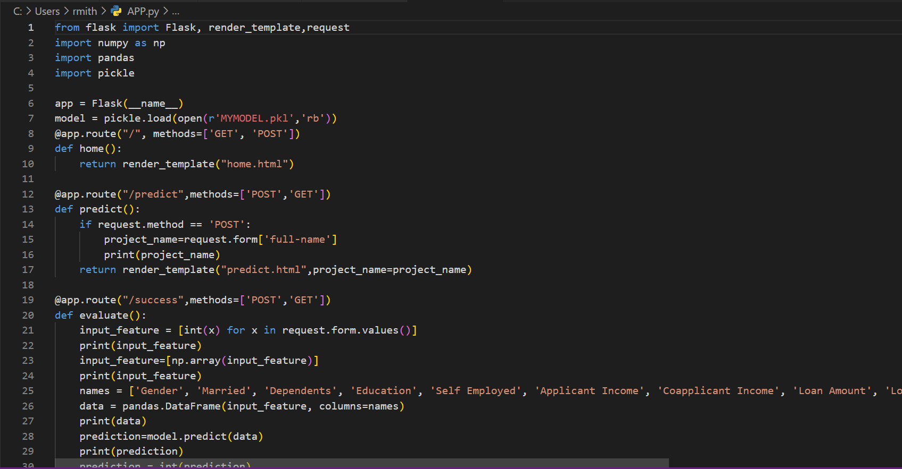

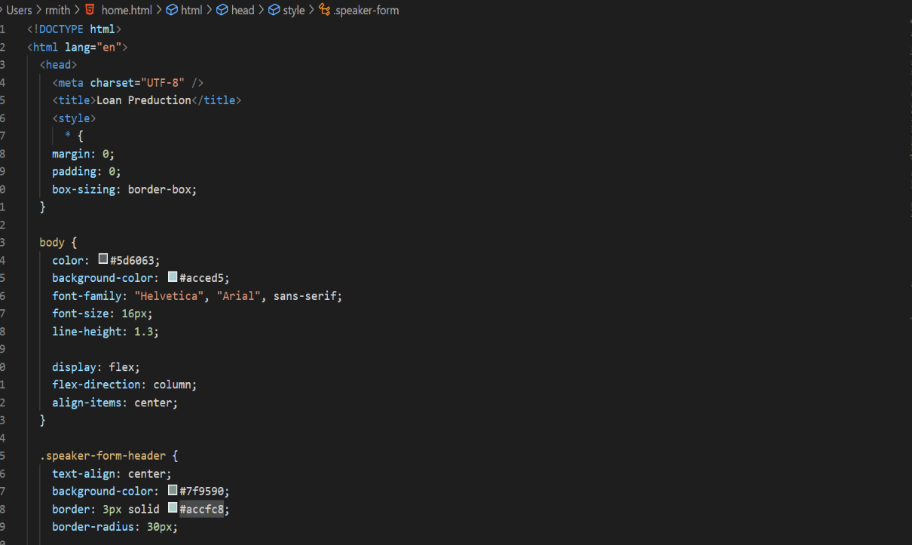

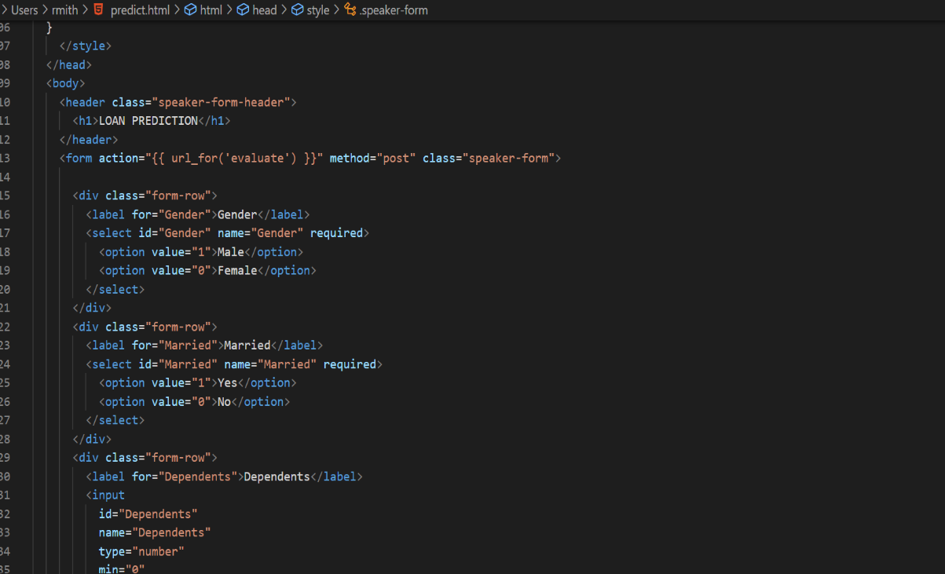

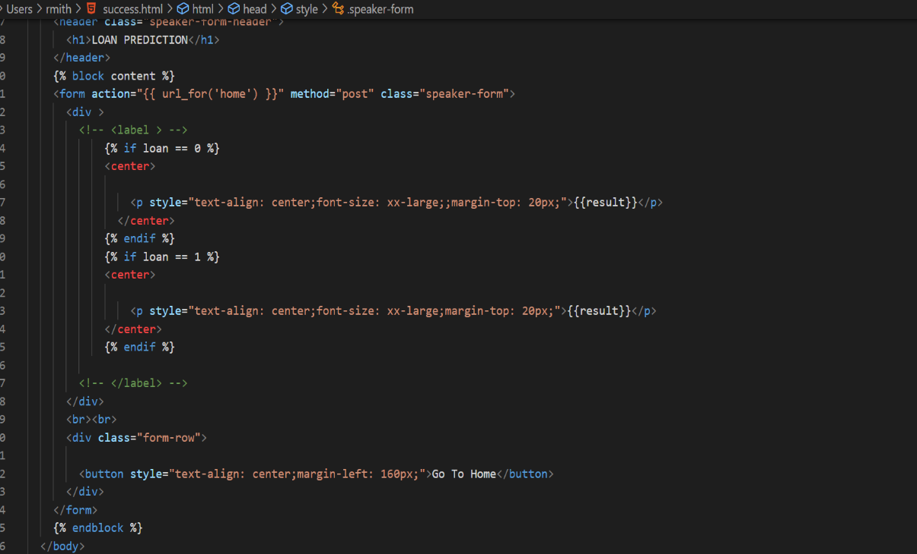

* 1. **7.2 FEATURE 2:** **THE MACHINE LEARNING MODEL PREDICTS THE APPLICANT’S ELIGIBILITY**

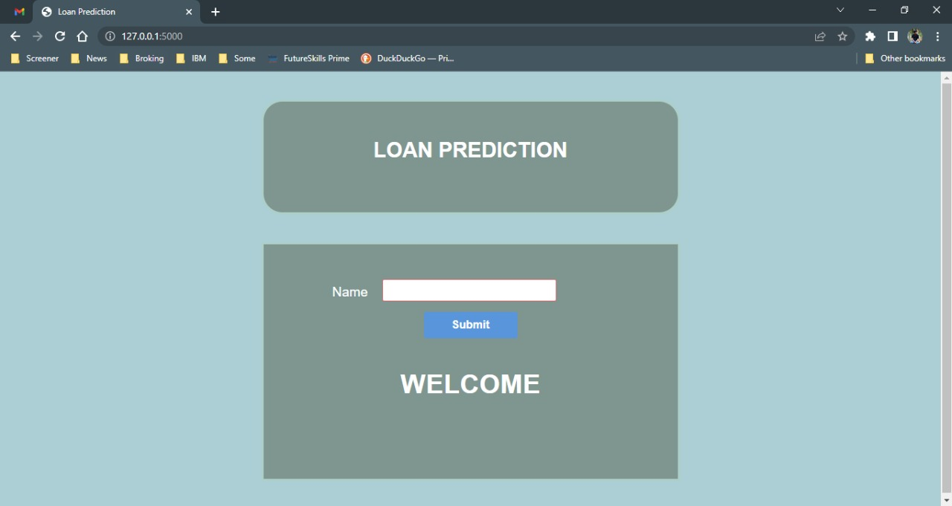

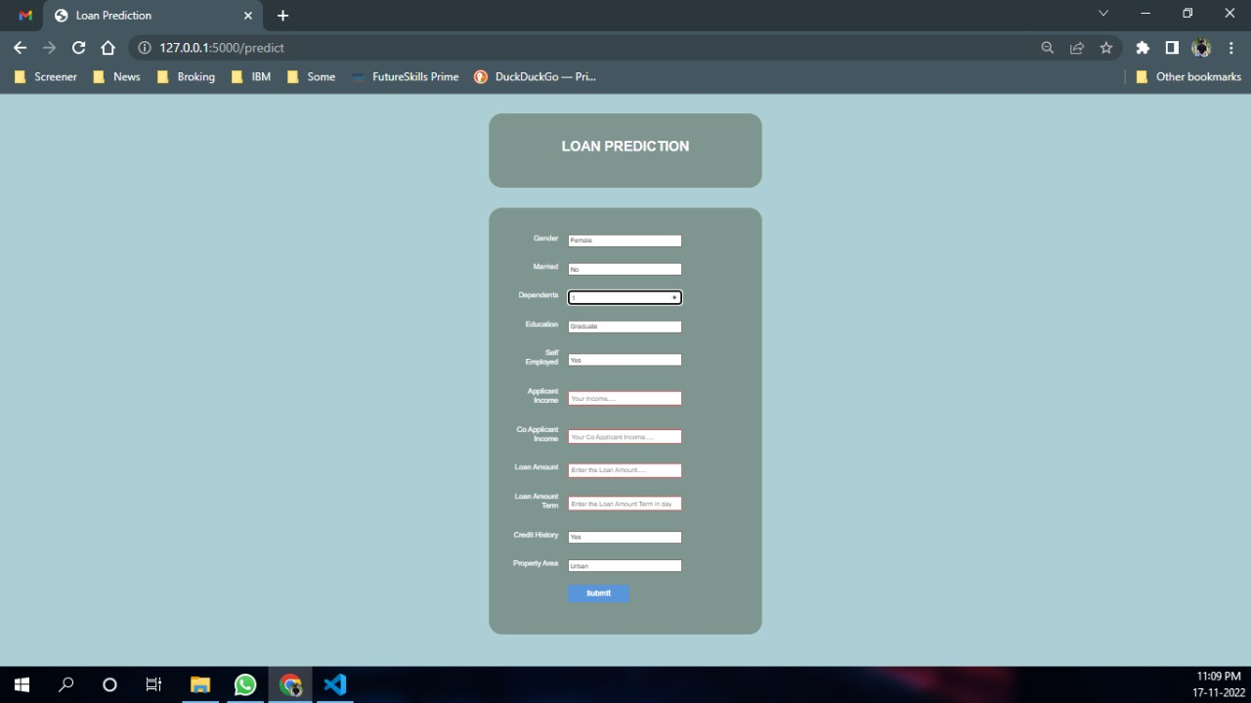

**8.TESTING**

**8.1 TEST CASES**

|  |  |  |  |  |  |  |  |  |  |  |  |  |
| --- | --- | --- | --- | --- | --- | --- | --- | --- | --- | --- | --- | --- |
| **Loan**  **_ID** | **Gen der** | **Mar ried** | **Depend ents** | **Educati on** | **Self- employed** | **Applicant Income** | **Co-applicant Income** | **Loan Amount** | **Loan Amount Term** | **Credit History** | **Property Area** | **Loan Status** |
| **LP00 1002** | Mal e | No | 0 | Graduate | No | 5849 | 0 |  | 360 | 1 | Urban | Y |
| **LP00 1003** | Mal e | Yes | 1 | Graduate | No | 4583 | 1508 | 128 | 360 | 1 | Rural | N |
| **LP00 1005** | Mal e | Yes | 0 | Graduate | Yes | 3000 | 0 | 66 | 360 | 1 | Urban | Y |
| **LP00 1006** | Mal e | Yes | 0 | Not Graduate | No | 2583 | 2358 | 120 | 360 | 1 | Urban | Y |
| **LP00 1008** | Mal e | No | 0 | Graduate | No | 6000 | 0 | 141 | 360 | 1 | Urban | Y |
| **LP00 1011** | Mal e | Yes | 2 | Graduate | Yes | 5417 | 4196 | 267 | 360 | 1 | Urban | Y |
| **LP00 1013** | Mal e | Yes | 0 | Not Graduate | No | 2333 | 1516 | 95 | 360 | 1 | Urban | Y |
| **LP00 1014** | Mal e | Yes | 3 | Graduate | No | 3036 | 2504 | 158 | 360 | 0 | Semiurba n | N |
| **LP00 1018** | Mal e | Yes | 2 | Graduate | No | 4006 | 1526 | 168 | 360 | 1 | Urban | Y |
| **LP00 1020** | Mal e | Yes | 1 | Graduate | No | 12841 | 10968 | 349 | 360 | 1 | Semiurba n | N |

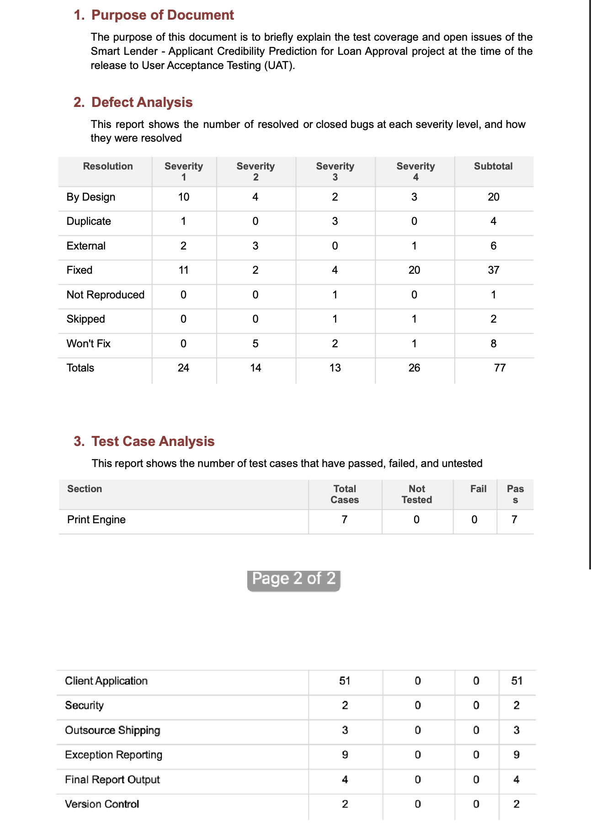**8.2 USER ACCECPTANCE TESTING**

**9. RESULTS**

**9.1 PERFORMANCE METRICS**

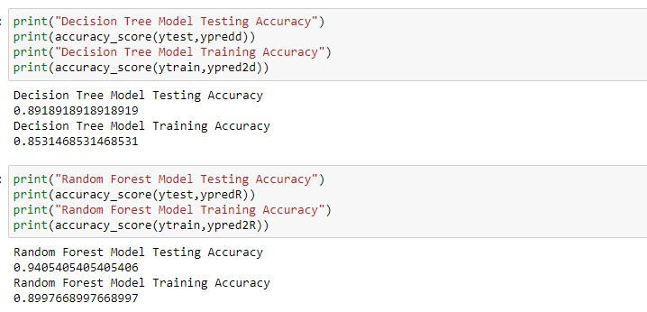

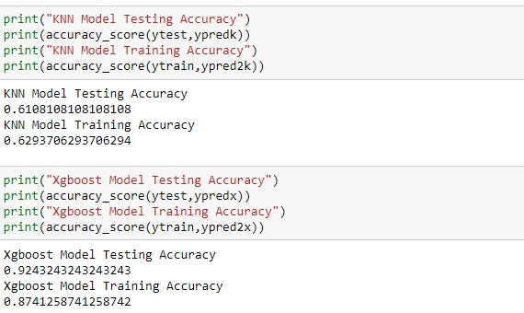

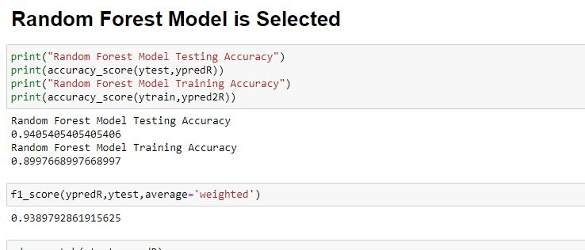

For the purpose of predicting the loan approval status of the applied customer, we have chosen the machine learning approach to study the bank dataset. We have applied various machine learning algorithms to decide which one will be the best for applying on the dataset to get the result with the highest accuracy. Most of the algorithm’s accuracy is between 70% -95%, with Random Forest Model having the highest accuracy of 94%.

We also determined the most important features that influence the loan approval status. These most important features are then used on some selected algorithms and their performance accuracy is compared with the instance of using all the features. This model can help the banks in figuring out which factors are important for the loan approval procedure. The comparative study makes us clear about which algorithm will be the best and ignores the rest, based on their accuracy.

**10.ADVANTAGES AND DISADVANTAGES**

**METRITS**

1. The benefit of this system is that by establishing specific conditions and defining the algorithms, we can determine whether a client meets the eligibility requirements simply by evaluating the details.
2. This system is created to forecast if a user's loan application will be granted by the bank based on inputs from the user such as salary, address, loan amount, and loan term.
3. This helps the banks to minimize the possible losses and can increase the volume of credits.
4. Assists the lender in analysing the situation.
5. Gives better services for use.
6. Reduce the risk factor by choosing the right person.
7. Save time and money for the lender.

**DEMERITS**

1. Instead of using machine learning techniques, they provided a mathematical model.
2. Class inequality was not addressed, nor were the required actions taken.

**11.CONCLUSION**

In order to eliminate human interference and boost productivity, the rapidly expanding IT sector of today needs to develop new technology and upgrade existing technology. It is abundantly obvious from the data analysis that it lessens all fraud committed at the time of loan acceptance. This application is operationally sound and complies with all banker specifications.

This component is simple to plug into numerous other systems. It operates properly, satisfies all bankers' needs, and is interconnected with numerous other systems. This prediction module can be enhanced and integrated more in the future. The system is trained using prior training data, but it is feasible to alter the software in the future so that it may accept new testing data as well as training data and predict as necessary.

**12.FUTURE SCOPE**

This paper work can be extended to higher level in future. Predictive model for loans that uses machine learning algorithms, where the results from each graph of the paper can be taken as individual criteria for the machine learning algorithm Z-score has been chosen over normalization (min-max scaling) for scaling the features. Classifiers such as support vector machine, logistic regression or neural network prefer standardization over normalization. Additionally, this paper proposes to use such feature extraction methodologies where maximizing the variance is highly preferred. This can be achieved using standardization. Furthermore, GridSearchCV has been used to optimize the hyperparameters of each classifier. Studies done in perfectly show the effectiveness of GridSearchCV in maximizing the performance of classifiers.

**13APPENDIX**

**SOURCE CODE**

**APP.py**

from flask import Flask, render_template,request

import numpy as np

import pandas

import pickle

app = Flask(__name__)

model = pickle.load(open(r'MYMODEL.pkl','rb'))

@app.route("/", methods=['GET', 'POST'])

def home():

return render_template("home.html")

@app.route("/predict",methods=['POST','GET'])

def predict():

if request.method == 'POST':

project_name=request.form['full-name']

print(project_name)

return render_template("predict.html",project_name=project_name)

@app.route("/success",methods=['POST','GET'])

def evaluate():

input_feature = [int(x) for x in request.form.values()]

print(input_feature)

input_feature=[np.array(input_feature)]

print(input_feature)

names = ['Gender', 'Married', 'Dependents', 'Education', 'Self Employed', 'Applicant Income', 'Coapplicant Income', 'Loan Amount', 'Loan_Amount_Term', 'Credit_History', 'Property_Area']

data = pandas.DataFrame(input_feature, columns=names)

print(data)

prediction=model.predict(data)

print(prediction)

prediction = int(prediction)

print(type(prediction))

loan=1

if (prediction == 0):

loan=0

return render_template("success.html",result = "Loan will Not be Approved",loan=loan)

else:

return render_template("success.html",result = "Loan will be Approved",loan=loan)

return render_template("success.html")

if __name__ == "__main__":

app.run(debug=True)

**Home.html**

<!DOCTYPE html>

<html lang="en">

<head>

<meta charset="UTF-8" />

<title>Loan Prediction</title>

<style>

* {

margin: 0;

padding: 0;

box-sizing: border-box;

}

body {

color: #5d6063;

background-color: #acced5;

font-family: "Helvetica", "Arial", sans-serif;

font-size: 16px;

line-height: 1.3;

display: flex;

flex-direction: column;

align-items: center;

}

.speaker-form-header {

text-align: center;

background-color: #7f9590;

border: 3px solid #accfc8;

border-radius: 30px;

width: 80%;

margin: 40px 0;

padding: 50px;

}

.speaker-form-header h1 {

font-size: 30px;

margin-bottom: 20px;

color: #fff;

}

.speaker-form {

background-color: #7f9590;

border: 3px solid #accfc8;

border-radius: 3px;

width: 80%;

padding: 50px;

margin: 0 0 40px 0;

}

.form-row {

margin-bottom: 40px;

display: flex;

justify-content: flex-start;

flex-direction: column;

flex-wrap: wrap;

}

.form-row input[type="text"],

.form-row input[type="number"] {

background-color: #ffffff;

border: 1px solid #d6d9dc;

border-radius: 3px;

width: 100%;

padding: 7px;

font-size: 14px;

}

.form-row label {

margin-bottom: 15px;

}

.form-row input[type="text"]:invalid,

.form-row input[type="number"]:invalid {

border: 1px solid #d55c5f;

color: #d55c5f;

box-shadow: none; /* Remove default red glow in Firefox */

}

.legacy-form-row {

border: none;

margin-bottom: 40px;

}

.legacy-form-row legend {

margin-bottom: 15px;

}

.legacy-form-row .radio-label {

display: block;

font-size: 14px;

padding: 0 20px 0 10px;

}

.legacy-form-row input[type="radio"] {

margin-top: 2px;

}

.legacy-form-row .radio-label,

.legacy-form-row input[type="radio"] {

float: left;

}

.form-row select {

width: 100%;

padding: 5px;

font-size: 14px; /* This won't work in Chrome or Safari */

-webkit-appearance: none; /* This will make it work */

}

.form-row textarea {

font-family: "Helvetica", "Arial", sans-serif;

font-size: 14px;

border: 1px solid #d6d9dc;

border-radius: 3px;

min-height: 200px;

margin-bottom: 10px;

padding: 7px;

resize: none;

}

.form-row .instructions {

color: #999999;

font-size: 14px;

margin-bottom: 30px;

}

.form-row .checkbox-label {

margin-bottom: 0;

}

.form-row button {

font-size: 16px;

font-weight: bold;

color: #ffffff;

background-color: #5995da;

border: none;

border-radius: 3px;

padding: 10px 40px;

cursor: pointer;

}

.form-row button:hover {

background-color: #76aeed;

}

.form-row button:active {

/* background-color: #407fc7; */

background-color: pink;

}

@media only screen and (min-width: 700px) {

.speaker-form-header,

.speaker-form {

width: 600px;

}

.form-row {

flex-direction: row;

align-items: flex-start; /* To avoid stretching */

margin-bottom: 20px;

}

.form-row input[type="text"],

.form-row input[type='number'], /* Add */

.form-row select, /* These */

.form-row textarea {

/* Selectors */

width: 250px;

height: initial;

}

.form-row label {

text-align: right;

width: 120px;

margin-top: 7px;

padding-right: 20px;

}

.legacy-form-row {

margin-bottom: 10px;

}

.legacy-form-row legend {

width: 120px;

text-align: right;

padding-right: 20px;

}

.legacy-form-row legend {

float: left;

}

.form-row .instructions {

margin-left: 120px;

}

.form-row .checkbox-label {

margin-left: 120px;

width: auto;

}

.form-row button {

margin-left: 120px;

}

.form-col{

flex-direction: column;

align-items: flex-start;

margin-bottom: 20px;

}

label{

color: #fff;

font-size: larger;

}

}

</style>

</head>

<body>

<header class="speaker-form-header">

<h1>LOAN PREDICTION</h1>

</header>

{% block content %}

<form action="{{ url_for('predict') }}" method="post" class="speaker-form">

<div class="form-col">

<div class="form-row">

<label for="full-name">Name</label>

<input id="full-name" name="full-name" type="text" autocomplete="off" required/>

<button style="text-align: center;margin-left: 180px;">Submit</button>

</div><br>

<div >

<label >

<center><h1>WELCOME</h1></center>

</label>

</div>

<br><br>

</div>

</form>

{% endblock %}

</body>

</html>

PREDICT.html

!DOCTYPE html>

<html lang="en">

<head>

<meta charset="UTF-8" />

<title>Loan Prediction</title>

<style>

* {

margin: 0;

padding: 0;

box-sizing: border-box;

}

body {

color: #5d6063;

background-color: #acced5;

font-family: "Helvetica", "Arial", sans-serif;

font-size: 16px;

line-height: 1.3;

display: flex;

flex-direction: column;

align-items: center;

}

.speaker-form-header {

text-align: center;

background-color: #7f9590;

border: 3px solid #accfc8;

border-radius: 30px;

width: 80%;

margin: 40px 0;

padding: 50px;

}

.speaker-form-header h1 {

font-size: 30px;

margin-bottom: 20px;

color: #fff;

}

.speaker-form {

background-color: #7f9590;

border: 3px solid #accfc8;

border-radius: 30px;

width: 80%;

padding: 50px;

margin: 0 0 40px 0;

}

.form-row {

margin-bottom: 40px;

display: flex;

justify-content: flex-start;

flex-direction: column;

flex-wrap: wrap;

}

.form-row input[type="text"],

.form-row input[type="number"] {

background-color: #ffffff;

border: 1px solid #d6d9dc;

border-radius: 3px;

width: 100%;

padding: 7px;

font-size: 14px;

}

.form-row label {

margin-bottom: 15px;

}

.form-row input[type="text"]:invalid,

.form-row input[type="number"]:invalid {

border: 1px solid #d55c5f;

color: #d55c5f;

box-shadow: none; /* Remove default red glow in Firefox */

}

.legacy-form-row {

border: none;

margin-bottom: 40px;

}

.legacy-form-row legend {

margin-bottom: 15px;

}

.legacy-form-row .radio-label {

display: block;

font-size: 14px;

padding: 0 20px 0 10px;

}

.legacy-form-row input[type="radio"] {

margin-top: 2px;

}

.legacy-form-row .radio-label,

.legacy-form-row input[type="radio"] {

float: left;

}

.form-row select {

width: 100%;

padding: 5px;

font-size: 14px; /* This won't work in Chrome or Safari */

-webkit-appearance: none; /* This will make it work */

}

.form-row textarea {

font-family: "Helvetica", "Arial", sans-serif;

font-size: 14px;

border: 1px solid #d6d9dc;

border-radius: 3px;

min-height: 200px;

margin-bottom: 10px;

padding: 7px;

resize: none;

}

.form-row .instructions {

color: #999999;

font-size: 14px;

margin-bottom: 30px;

}

.form-row .checkbox-label {

margin-bottom: 0;

}

.form-row button {

font-size: 16px;

font-weight: bold;

color: #ffffff;

background-color: #5995da;

border: none;

border-radius: 3px;

padding: 10px 40px;

cursor: pointer;

}

.form-row button:hover {

background-color: #76aeed;

}

.form-row button:active {

/* background-color: #407fc7; */

background-color: pink;

}

@media only screen and (min-width: 700px) {

.speaker-form-header,

.speaker-form {

width: 600px;

}

.form-row {

flex-direction: row;

align-items: center; /* To avoid stretching */

margin-bottom: 20px;

}

.form-row input[type="text"],

.form-row input[type='number'], /* Add */

.form-row select, /* These */

.form-row textarea {

/* Selectors */

width: 250px;

height: initial;

}

.form-row label {

text-align: right;

width: 120px;

margin-top: 7px;

padding-right: 20px;

}

.legacy-form-row {

margin-bottom: 10px;

}

.legacy-form-row legend {

width: 120px;

text-align: right;

padding-right: 20px;

}

.legacy-form-row legend {

float: left;

}

.form-row .instructions {

margin-left: 120px;

}

.form-row .checkbox-label {

margin-left: 120px;

width: auto;

}

.form-row button {

margin-left: 120px;

}

label{

color: #fff;

}

}

</style>

</head>

<body>

<header class="speaker-form-header">

<h1>LOAN PREDICTION</h1>

</header>

<form action="{{ url_for('evaluate') }}" method="post" class="speaker-form">

<div class="form-row">

<label for="Gender">Gender</label>

<select id="Gender" name="Gender" required>

<option value="1">Male</option>

<option value="0">Female</option>

</select>

</div>

<div class="form-row">

<label for="Married">Married</label>

<select id="Married" name="Married" required>

<option value="1">Yes</option>

<option value="0">No</option>

</select>

</div>

<div class="form-row">

<label for="Dependents">Dependents</label>

<input

id="Dependents"

name="Dependents"

type="number"

min="0"

max="3"

placeholder="No of Dependents on you....."

required

/>

</div>

<div class="form-row">

<label for="Education">Education</label>

<select id="Education" name="Education" required>

<option value="0">Graduate</option>

<option value="1">Not Graduate</option>

</select>

</div>

<div class="form-row">

<label for="Self Employed">Self Employed</label>

<select id="Self Employed" name="Self Employed" required>

<option value="1">Yes</option>

<option value="0">No</option>

</select>

</div>

<div class="form-row">

<label for="Applicant Income">Applicant Income</label>

<input

id="Applicant Income"

name="Applicant Income"

type="number"

min="0"

placeholder="Your Income....."

required

/>

</div>

<div class="form-row">

<label for="Co Applicant Income">Co Applicant Income</label>

<input

id="Co Applicant Income"

name="Co Applicant Income"

type="number"

min="0"

placeholder="Your Co Applicant Income....."

required

/>

</div>

<div class="form-row">

<label for="Loan Amount">Loan Amount</label>

<input

id="Loan Amount"

name="Loan Amount"

type="number"

min="0"

placeholder="Enter the Loan Amount....."

required

/>

</div>

<div class="form-row">

<label for="Loan Amount Term">Loan Amount Term</label>

<input

id="Loan Amount Term"

name="Loan Amount Term"

type="number"

min="0"

placeholder="Enter the Loan Amount Term in days....."

required

/>

</div>

<div class="form-row">

<label for="Credit History">Credit History</label>

<select id="Credit History" name="Credit History" required>

<option value="1">Yes</option>

<option value="0">No</option>

</select>

</div>

<div class="form-row">

<label for="Property Area">Property Area</label>

<select id="Property Area" name="Property Area" required>

<option value="0">Urban</option>

<option value="1">Semiurban</option>

<option value="2">Rural</option>

</select>

</div>

<!-- <div class="form-row">

<label for="abstract">Abstract</label>

<textarea id="abstract" name="abstract"></textarea>

<div class="instructions">Describe your talk in 500 words or less</div>

</div>

<div class="form-row">

<label class="checkbox-label" for="available">

<input

id="available"

name="available"

type="checkbox"

value="is-available"

/>

<span>I’m actually available the date of the talk</span>

</label>

</div> -->

<div class="form-row">

<button>Submit</button>

</div>

</form>

</body>

</html>

<!DOCTYPE html>

<html lang="en">

<head>

<meta charset="UTF-8" />

<title>Loan Prediction</title>

<style>

* {

margin: 0;

padding: 0;

box-sizing: border-box;

}

body {

color: #5d6063;

background-color: #acced5;

font-family: "Helvetica", "Arial", sans-serif;

font-size: 16px;

line-height: 1.3;

display: flex;

flex-direction: column;

align-items: center;

}

.speaker-form-header {

text-align: center;

background-color: #7f9590;

border: 3px solid #accfc8;

border-radius: 30px;

width: 80%;

margin: 40px 0;

padding: 50px;

}

.speaker-form-header h1 {

font-size: 30px;

margin-bottom: 20px;

color: #fff;

}

.speaker-form {

background-color: #7f9590;

border: 3px solid #accfc8;

border-radius: 30px;

width: 80%;

padding: 50px;

margin: 0 0 40px 0;

}

.form-row {

margin-bottom: 40px;

display: flex;

justify-content: flex-start;

flex-direction: column;

flex-wrap: wrap;

}

.form-row input[type="text"],

.form-row input[type="number"] {

background-color: #ffffff;

border: 1px solid #d6d9dc;

border-radius: 3px;

width: 100%;

padding: 7px;

font-size: 14px;

}

.form-row label {

margin-bottom: 15px;

}

.form-row input[type="text"]:invalid,

.form-row input[type="number"]:invalid {

border: 1px solid #d55c5f;

color: #d55c5f;

box-shadow: none; /* Remove default red glow in Firefox */

}

.legacy-form-row {

border: none;

margin-bottom: 40px;

}

.legacy-form-row legend {

margin-bottom: 15px;

}

.legacy-form-row .radio-label {

display: block;

font-size: 14px;

padding: 0 20px 0 10px;

}

.legacy-form-row input[type="radio"] {

margin-top: 2px;

}

.legacy-form-row .radio-label,

.legacy-form-row input[type="radio"] {

float: left;

}

.form-row select {

width: 100%;

padding: 5px;

font-size: 14px; /* This won't work in Chrome or Safari */

-webkit-appearance: none; /* This will make it work */

}

.form-row textarea {

font-family: "Helvetica", "Arial", sans-serif;

font-size: 14px;

border: 1px solid #d6d9dc;

border-radius: 3px;

min-height: 200px;

margin-bottom: 10px;

padding: 7px;

resize: none;

}

.form-row .instructions {

color: #999999;

font-size: 14px;

margin-bottom: 30px;

}

.form-row .checkbox-label {

margin-bottom: 0;

}

.form-row button {

font-size: 16px;

font-weight: bold;

color: #ffffff;

background-color: #5995da;

border: none;

border-radius: 3px;

padding: 10px 40px;

cursor: pointer;

}

.form-row button:hover {

background-color: #76aeed;

}

.form-row button:active {

/* background-color: #407fc7; */

background-color: pink;

}

@media only screen and (min-width: 700px) {

.speaker-form-header,

.speaker-form {

width: 600px;

}

.form-row {

flex-direction: row;

align-items: center; /* To avoid stretching */

margin-bottom: 20px;

}

.form-row input[type="text"],

.form-row input[type='number'], /* Add */

.form-row select, /* These */

.form-row textarea {

/* Selectors */

width: 250px;

height: initial;

}

.form-row label {

text-align: right;

width: 120px;

margin-top: 7px;

padding-right: 20px;

}

.legacy-form-row {

margin-bottom: 10px;

}

.legacy-form-row legend {

width: 120px;

text-align: right;

padding-right: 20px;

}

.legacy-form-row legend {

float: left;

}

.form-row .instructions {

margin-left: 120px;

}

.form-row .checkbox-label {

margin-left: 120px;

width: auto;

}

.form-row button {

margin-left: 120px;

}

label{

color: #fff;

}

}

</style>

</head>

<body>

<header class="speaker-form-header">

<h1>LOAN PREDICTION</h1>

</header>

<form action="{{ url_for('evaluate') }}" method="post" class="speaker-form">

<div class="form-row">

<label for="Gender">Gender</label>

<select id="Gender" name="Gender" required>

<option value="1">Male</option>

<option value="0">Female</option>

</select>

</div>

<div class="form-row">

<label for="Married">Married</label>

<select id="Married" name="Married" required>

<option value="1">Yes</option>

<option value="0">No</option>

</select>

</div>

<div class="form-row">

<label for="Dependents">Dependents</label>

<input

id="Dependents"

name="Dependents"

type="number"

min="0"

max="3"

placeholder="No of Dependents on you....."

required

/>

</div>

<div class="form-row">

<label for="Education">Education</label>

<select id="Education" name="Education" required>

<option value="0">Graduate</option>

<option value="1">Not Graduate</option>

</select>

</div>

<div class="form-row">

<label for="Self Employed">Self Employed</label>

<select id="Self Employed" name="Self Employed" required>

<option value="1">Yes</option>

<option value="0">No</option>

</select>

</div>

<div class="form-row">

<label for="Applicant Income">Applicant Income</label>

<input

id="Applicant Income"

name="Applicant Income"

type="number"

min="0"

placeholder="Your Income....."

required

/>

</div>

<div class="form-row">

<label for="Co Applicant Income">Co Applicant Income</label>

<input

id="Co Applicant Income"

name="Co Applicant Income"

type="number"

min="0"

placeholder="Your Co Applicant Income....."

required

/>

</div>

<div class="form-row">

<label for="Loan Amount">Loan Amount</label>

<input

id="Loan Amount"

name="Loan Amount"

type="number"

min="0"

placeholder="Enter the Loan Amount....."

required

/>

</div>

<div class="form-row">

<label for="Loan Amount Term">Loan Amount Term</label>

<input

id="Loan Amount Term"

name="Loan Amount Term"

type="number"

min="0"

placeholder="Enter the Loan Amount Term in days....."

required

/>

</div>

<div class="form-row">

<label for="Credit History">Credit History</label>

<select id="Credit History" name="Credit History" required>

<option value="1">Yes</option>

<option value="0">No</option>

</select>

</div>

<div class="form-row">

<label for="Property Area">Property Area</label>

<select id="Property Area" name="Property Area" required>

<option value="0">Urban</option>

<option value="1">Semiurban</option>

<option value="2">Rural</option>

</select>

</div>

<!-- <div class="form-row">

<label for="abstract">Abstract</label>

<textarea id="abstract" name="abstract"></textarea>

<div class="instructions">Describe your talk in 500 words or less</div>

</div>

<div class="form-row">

<label class="checkbox-label" for="available">

<input

id="available"

name="available"

type="checkbox"

value="is-available"

/>

<span>I’m actually available the date of the talk</span>

</label>

</div> -->

<div class="form-row">

<button>Submit</button>

</div>

</form>

</body>

</html>

**SUCCESS.html**

<!DOCTYPE html>

<html lang="en">

<head>

<meta charset="UTF-8" />

<title>Loan Prediction</title>

<style>

* {

margin: 0;

padding: 0;

box-sizing: border-box;

}

body {

color: #5d6063;

background-color: #acced5;

font-family: "Helvetica", "Arial", sans-serif;

font-size: 16px;

line-height: 1.3;

display: flex;

flex-direction: column;

align-items: center;

}

.speaker-form-header {

text-align: center;

background-color: #7f9590;

border: 3px solid #accfc8;

border-radius: 30px;

width: 80%;

margin: 40px 0;

padding: 50px;

}

.speaker-form-header h1 {

font-size: 30px;

margin-bottom: 20px;

color: #fff;

}

.speaker-form {

background-color: #7f9590;

border: 3px solid #accfc8;

border-radius: 30px;

width: 80%;

padding: 50px;

margin: 0 0 40px 0;

}

.form-row {

margin-bottom: 40px;

display: flex;

justify-content: flex-start;

flex-direction: column;

flex-wrap: wrap;

}

.form-row input[type="text"],

.form-row input[type="number"] {

background-color: #ffffff;

border: 3px solid #d6d9dc;

border-radius: 30px;

width: 100%;

padding: 7px;

font-size: 14px;

}

.form-row label {

margin-bottom: 15px;

}

.form-row input[type="text"]:invalid,

.form-row input[type="number"]:invalid {

border: 1px solid #d55c5f;

color: #d55c5f;

box-shadow: none; /* Remove default red glow in Firefox */

}

.legacy-form-row {

border: none;

margin-bottom: 40px;

}

.legacy-form-row legend {

margin-bottom: 15px;

}

.legacy-form-row .radio-label {

display: block;

font-size: 14px;

padding: 0 20px 0 10px;

}

.legacy-form-row input[type="radio"] {

margin-top: 2px;

}

.legacy-form-row .radio-label,

.legacy-form-row input[type="radio"] {

float: left;

}

.form-row select {

width: 100%;

padding: 5px;

font-size: 14px; /* This won't work in Chrome or Safari */

-webkit-appearance: none; /* This will make it work */

}

.form-row textarea {

font-family: "Helvetica", "Arial", sans-serif;

font-size: 14px;

border: 1px solid #d6d9dc;

border-radius: 3px;

min-height: 200px;

margin-bottom: 10px;

padding: 7px;

resize: none;

}

.form-row .instructions {

color: #999999;

font-size: 14px;

margin-bottom: 30px;

}

.form-row .checkbox-label {

margin-bottom: 0;

}

.form-row button {

font-size: 16px;

font-weight: bold;

color: #ffffff;

background-color: #5995da;

border: none;

border-radius: 3px;

padding: 10px 40px;

cursor: pointer;

}

.form-row button:hover {

background-color: #76aeed;

}

.form-row button:active {

/* background-color: #407fc7; */

background-color: pink;

}

@media only screen and (min-width: 700px) {

.speaker-form-header,

.speaker-form {

width: 600px;

}

.form-row {

flex-direction: row;

align-items: flex-start; /* To avoid stretching */

margin-bottom: 20px;

}

.form-row input[type="text"],

.form-row input[type='number'], /* Add */

.form-row select, /* These */

.form-row textarea {

/* Selectors */

width: 250px;

height: initial;

}

.form-row label {

text-align: right;

width: 120px;

margin-top: 7px;

padding-right: 20px;

}

.legacy-form-row {

margin-bottom: 10px;

}

.legacy-form-row legend {

width: 120px;

text-align: right;

padding-right: 20px;

}

.legacy-form-row legend {

float: left;

}

.form-row .instructions {

margin-left: 120px;

}

.form-row .checkbox-label {

margin-left: 120px;

width: auto;

}

.form-row button {

margin-left: 120px;

}

}

</style>

</head>

<body>

<header class="speaker-form-header">

<h1>LOAN PREDICTION</h1>

</header>

{% block content %}

<form action="{{ url_for('home') }}" method="post" class="speaker-form">

<div >

<!-- <label > -->

{% if loan == 0 %}

<center>

<p style="text-align: center;font-size: xx-large;;margin-top: 20px;">{{result}}</p>

</center>

{% endif %}

{% if loan == 1 %}

<center>

<p style="text-align: center;font-size: xx-large;margin-top: 20px;">{{result}}</p>

</center>

{% endif %}

<!-- </label> -->

</div>

<br><br>

<div class="form-row">

<button style="text-align: center;margin-left: 160px;">Go To Home</button>

</div>

</form>

{% endblock %}

</body>

</html>

**GITHUB LINK :**